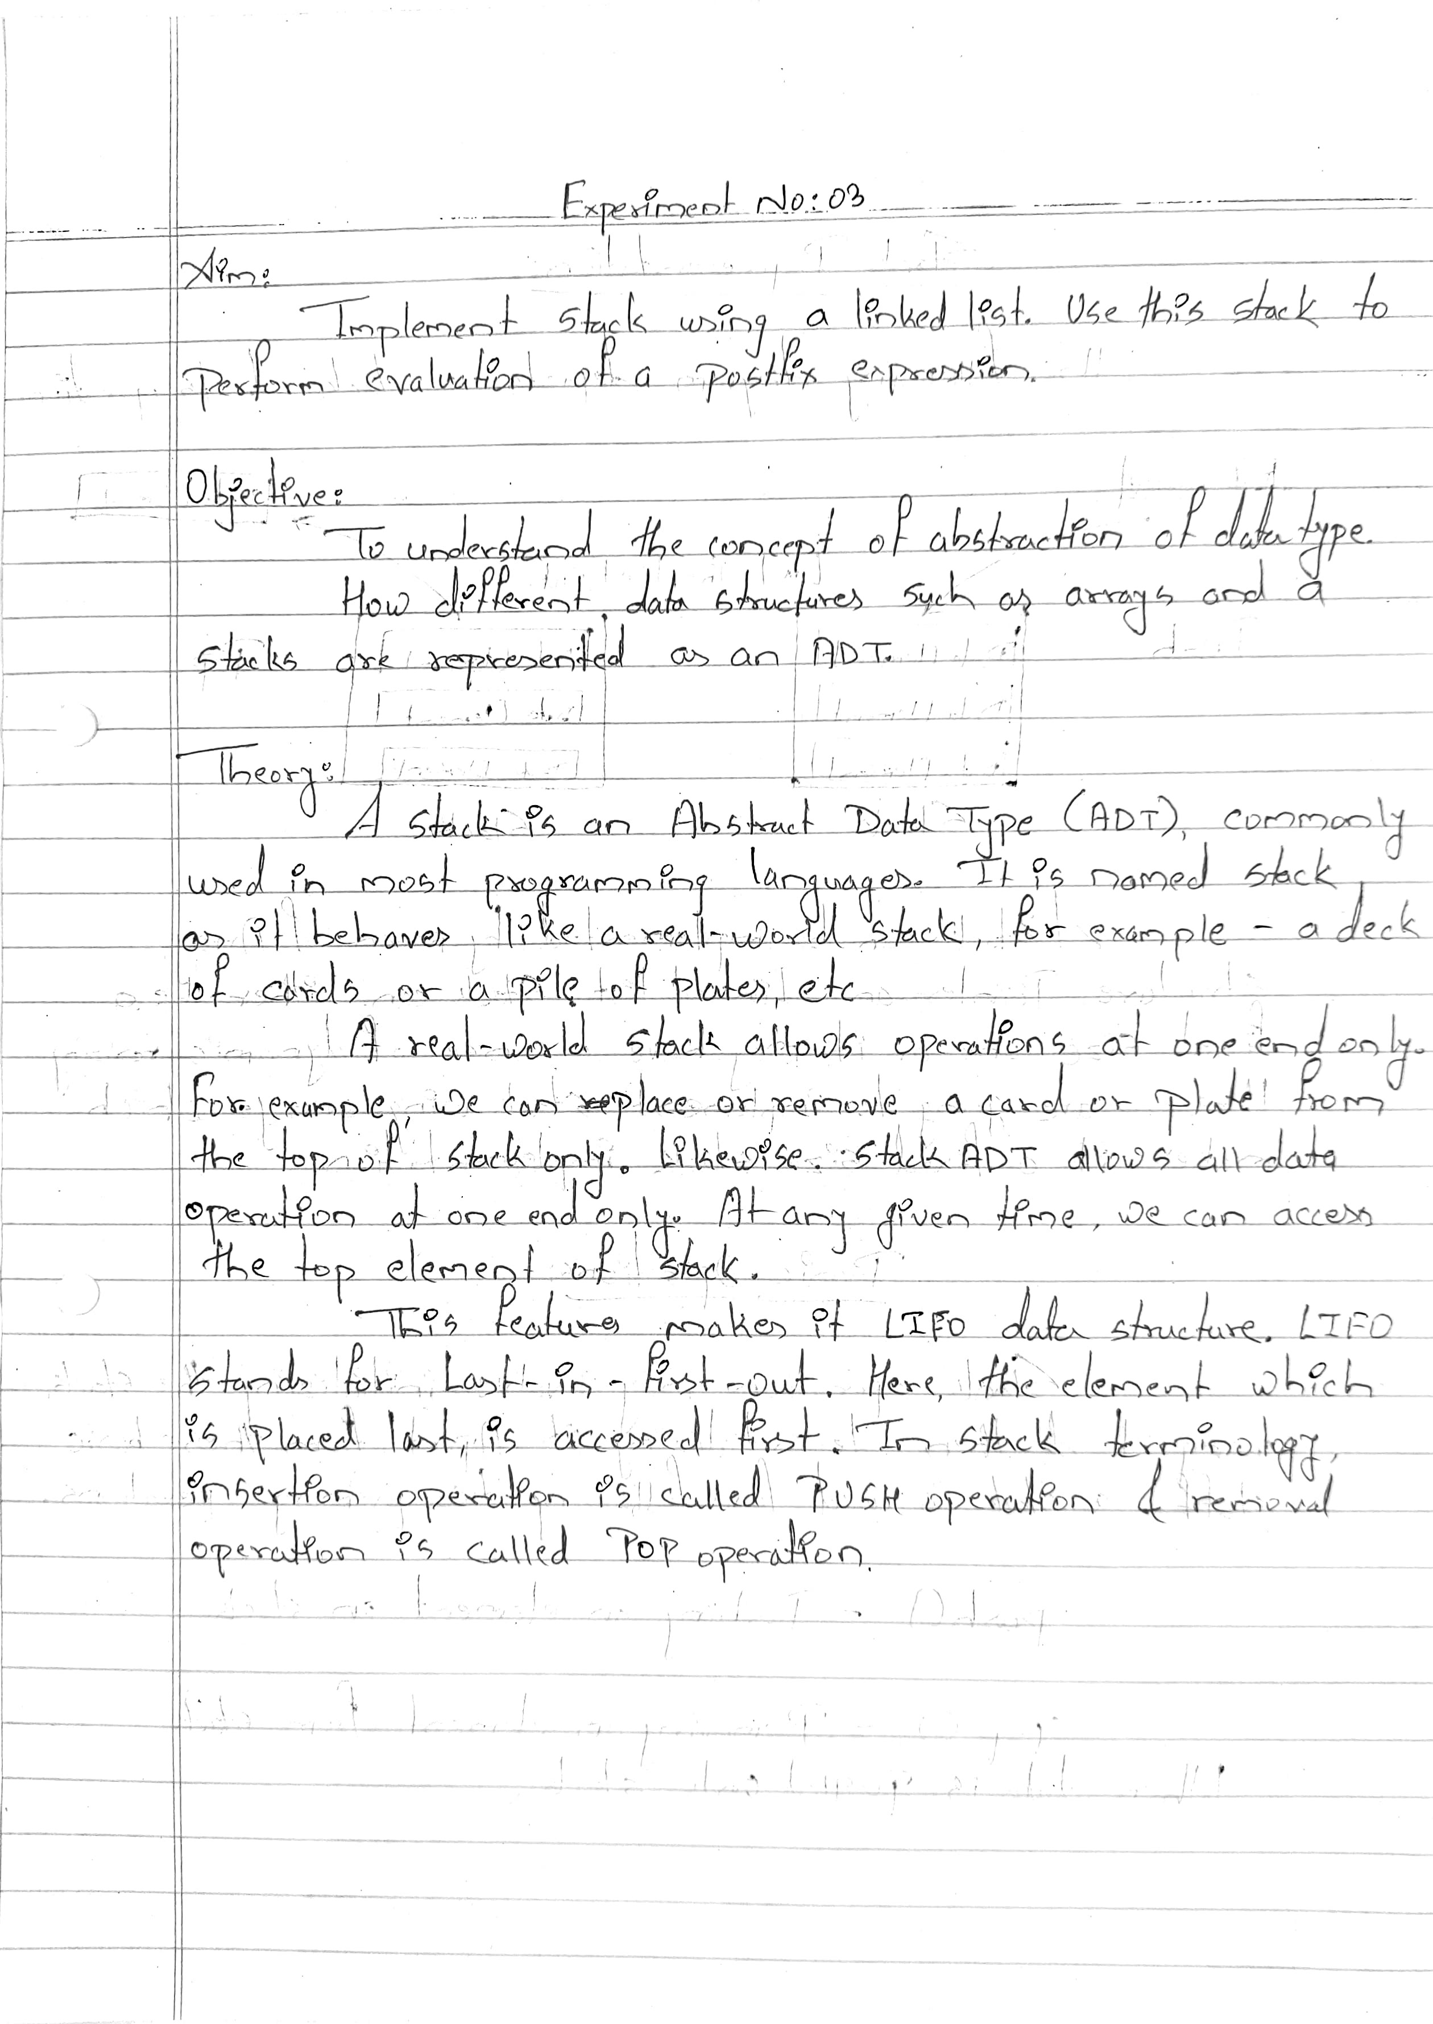

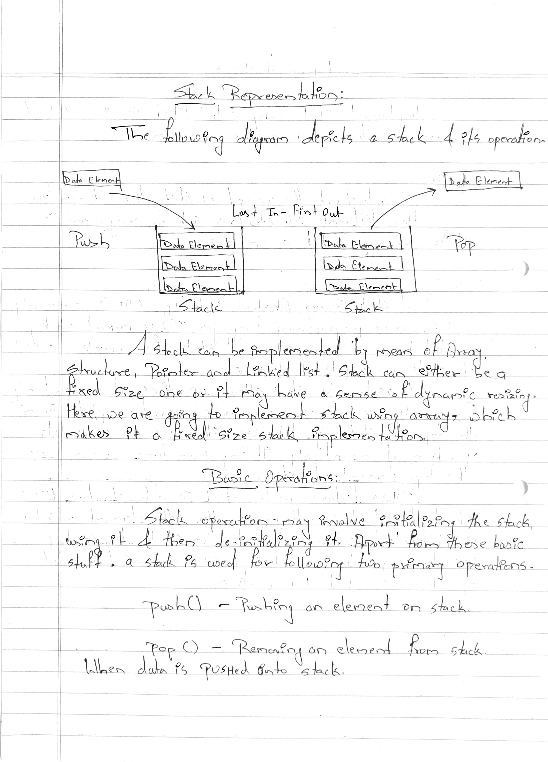

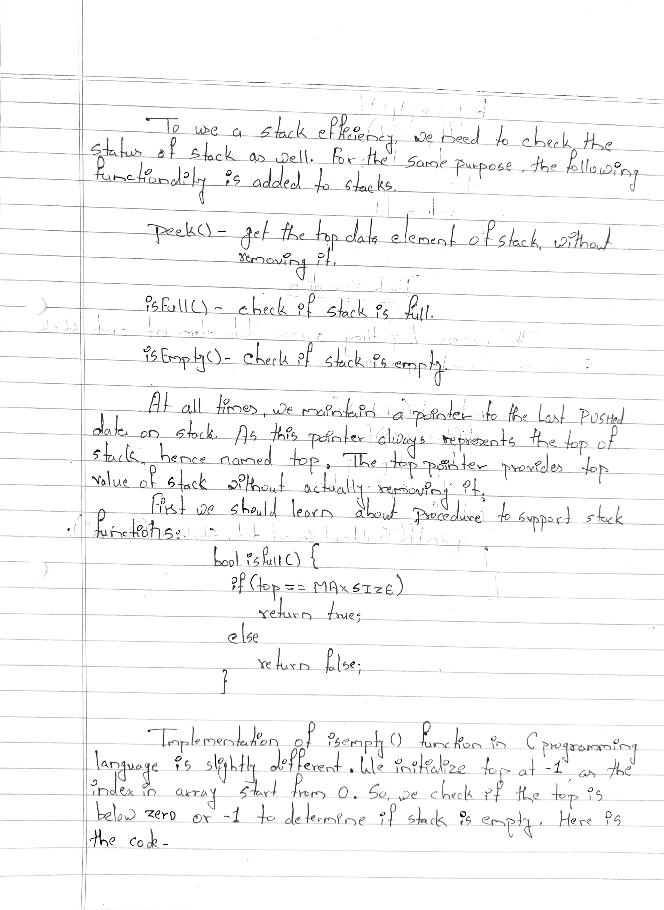

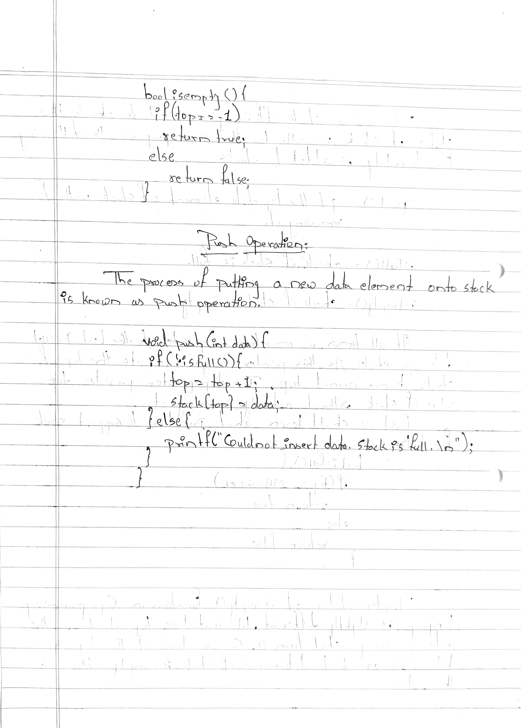

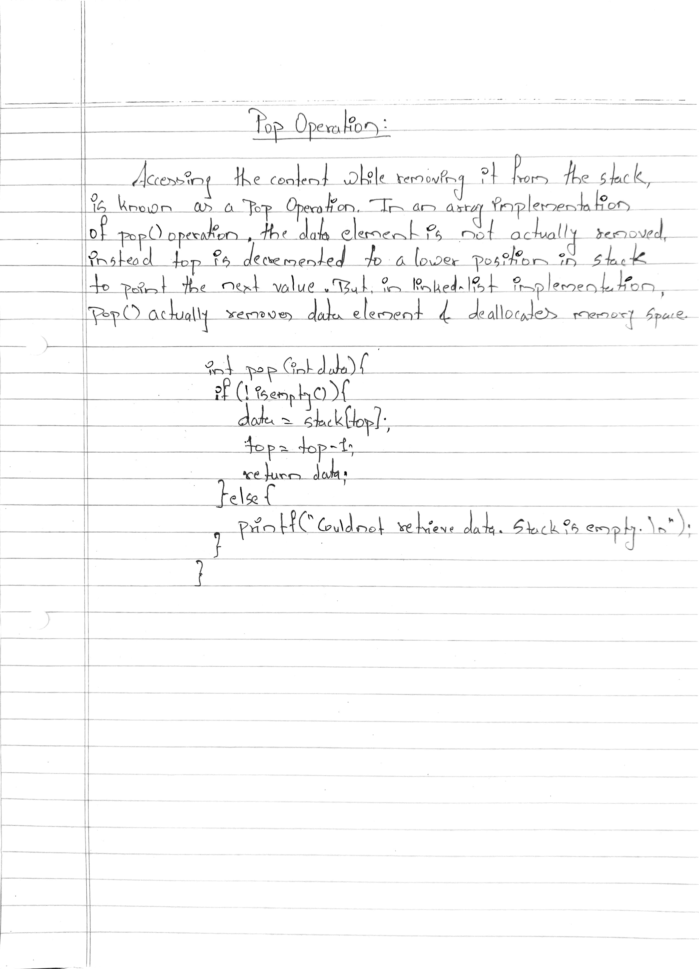

**Program Code:**

#include <iostream>

#include <stdlib.h>

#include <string.h>

#include <ctype.h>

using namespace std;

struct node {

int data;

struct node * next;

};

struct node * top = NULL;

/* create a new node with the given data */

struct node * createNode(int data) {

struct node * ptr = (struct node * ) malloc(sizeof(struct node));

ptr -> data = data;

ptr -> next = NULL;

}

/* push the input data into the stack */

void push(int data) {

struct node * ptr = createNode(data);

if (top == NULL) {

top = ptr;

return;

}

ptr -> next = top;

top = ptr;

}

/* pop the top element from the stack */

int pop() {

int data;

struct node * temp;

if (top == NULL)

return -1;

data = top -> data;

temp = top;

top = top -> next;

free(temp);

return (data);

}

int main() {

// 6 2 * 3 4 10 / - +

char str[100];

int i, data = -1, operand1, operand2, result;

/* i/p postfix expr from the user */

cout << "Enter your postfix expression: ";

fgets(str, 100, stdin);

for (i = 0; i < strlen(str); i++) {

if (isdigit(str[i])) {

/* if the i/p char is digit, parse character by character to get complete operand*/

data = (data == -1) ? 0 : data;

data = (data * 10) + (str[i] - 48);

continue;

}

/* push the operator into the stack */

if (data != -1) {

push(data);

}

if (str[i] == '+' || str[i] == '-' || str[i] == '*' || str[i] == '/') {

/*

* if the i/p character is an operator,

* then pop two elements from the stack,

* apply operator and push the result into

* the stack

*/

operand2 = pop();

operand1 = pop();

if (operand1 == -1 || operand2 == -1)

break;

switch (str[i]) {

case '+':

result = operand1 + operand2;

/* pushing result into the stack */

push(result);

break;

case '-':

result = operand1 - operand2;

push(result);

break;

case '*':

result = operand1 * operand2;

push(result);

break;

case '/':

result = operand1 / operand2;

push(result);

break;

}

}

data = -1;

}

if (top != NULL && top -> next == NULL)

cout << "Output:" << top -> data;

else

cout << "You have entered wrong expression\n";

return 0;

}

**Program Output:**

